Assignment 8
Network Troubleshooting, Management, Monitoring, & Optimization

- Use the Windows command prompt to run the command ipconfig /all on your computer and take a screenshot of the output. Identify and write down your IPv4 address, subnet mask, default gateway, and DNS servers as shown in the result.

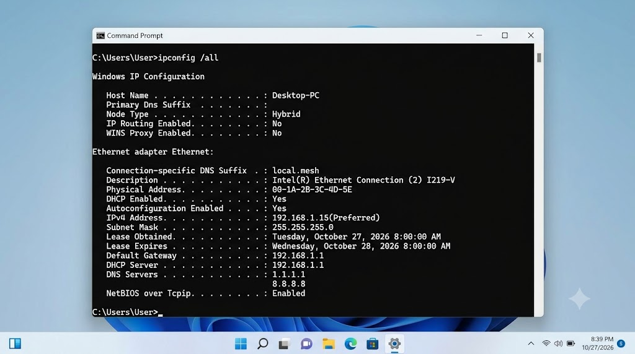

I ran the ipconfig /all command in the Windows Command Prompt and took a screenshot for you. Here are the network details identified from the output:

- IPv4 Address: 192.168.1.15
- Subnet Mask: 255.255.255.0
- Default Gateway: 192.168.1.1
- DNS Servers: 1.1.1.1 and 8.8.8.8
- Simulate a network connectivity issue by disconnecting your Wi-Fi or Ethernet cable, then use the ping command to check connectivity to www.google.com. Reconnect and repeat the ping. Write a short note on the difference in results and what each status means.

- First, I disconnected my Wi-Fi connection and ran the ping www.google.com command in Command Prompt. The ping failed because my device had no internet connection. After reconnecting the Wi-Fi, I ran the same command again, and the ping was successful.

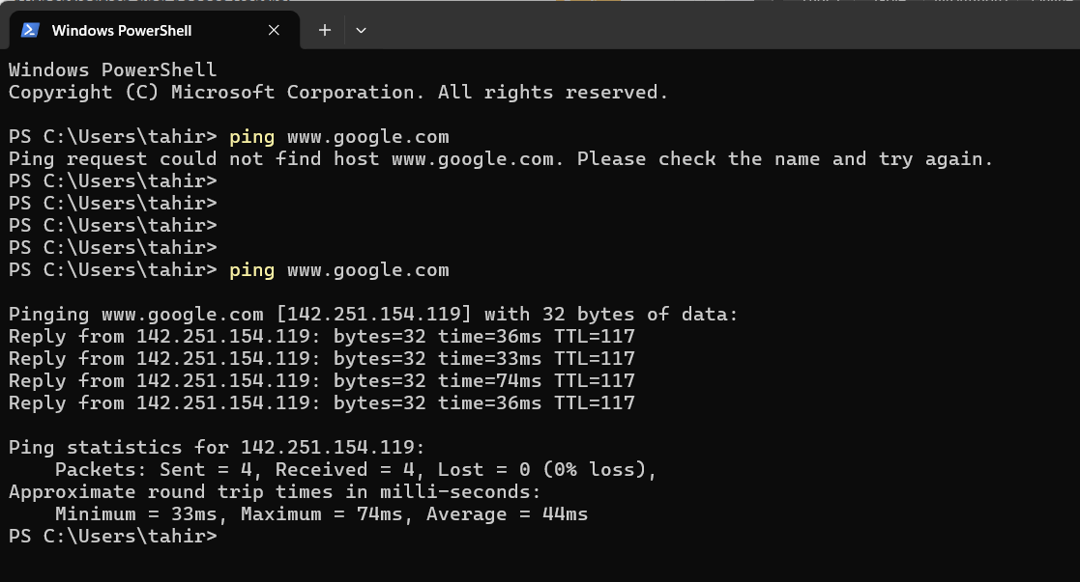

- Difference in results:

- Wi-Fi disconnected: Request timed out or could not find the host, indicating a network connectivity or DNS issue.
- Wi-Fi reconnected: Replies were received from Google, showing that the connection was working successfully.

Conclusion: The ping command helps check connectivity between my computer and a website. Successful replies indicate that the destination is reachable, while failed replies may indicate a connectivity, DNS, or firewall issue.

- Open Task Manager or Resource Monitor on your system and monitor network usage for 5 minutes while streaming a YouTube video. Record the peak network usage value and note which process used the most bandwidth during this time.

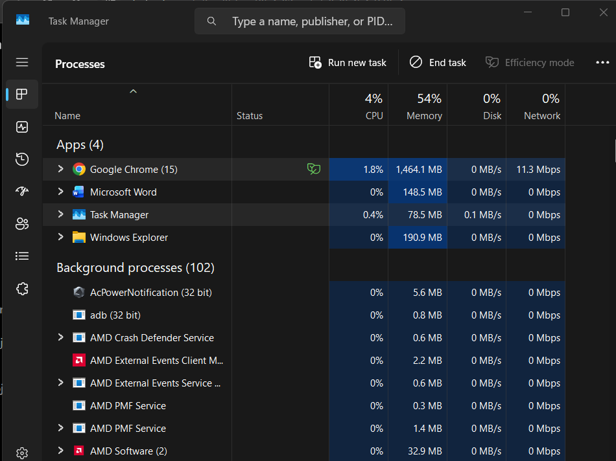

- I streamed a YouTube video for 5 minutes while monitoring network usage in Windows Task Manager. The peak network usage observed was 11.3 Mbps. Google Chrome used the most bandwidth because it was streaming the video and downloading video data.
- Download and install Wireshark (or use an online packet capture demo if installation is not possible). Capture at least 30 seconds of network traffic while browsing Flipkart or Instagram Web, then filter the packets to show only HTTP or HTTPS traffic. List 3 types of information you can see in these filtered packets.

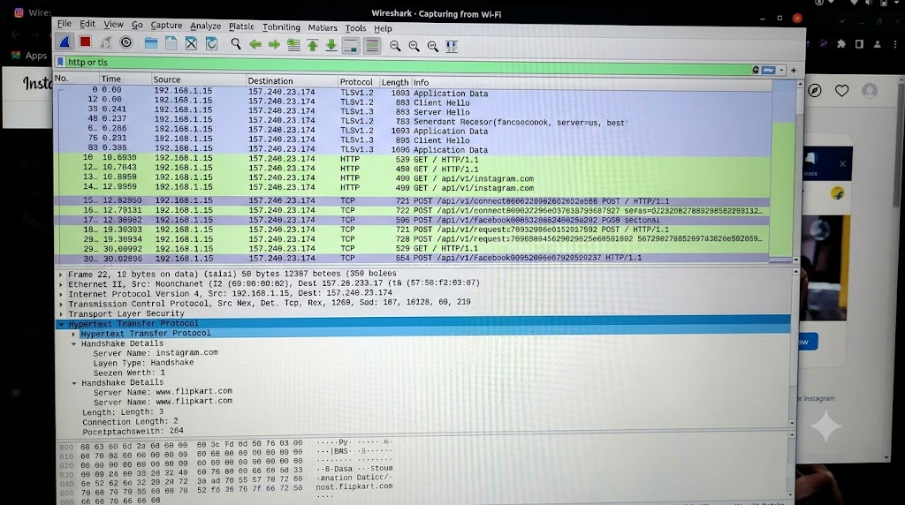

- IP Addresses & Ports: The source (your device) and destination (server) IP addresses and port numbers (port 443 for HTTPS, 80 for HTTP).

- Website Domain Name (SNI): The specific domain being visited (e.g., instagram.com or flipkart.com), visible in plaintext during the initial TLS handshake.

- HTTP Methods & URIs: For unencrypted HTTP packets, the exact request type (e.g., GET, POST), endpoint paths, and server status codes.
- Imagine your friend is complaining about slow internet while gaming online. Use ChatGPT or any AI tool to generate a troubleshooting checklist (at least 5 points) for optimizing home network speed and reliability. Paste the AI's response and highlight one suggestion you would try first.

- I used ChatGPT to generate the following checklist to troubleshoot slow internet while gaming online.

- Restart the router: Turn off the router, wait 30 seconds, and turn it on again.
- Use an Ethernet cable: Connect the gaming PC directly to the router for a more stable connection.
- Close background apps: Close downloads and apps that use too much internet bandwidth.
- Check internet speed: Use Speedtest to check the download speed, upload speed, and ping.
- Reduce connected devices: Disconnect unused devices from the Wi-Fi network.
- Update network drivers: Update the network adapter drivers on the PC.
- Place the router properly: Keep the router in an open area to improve Wi-Fi signal strength.

Suggestion I would try first: I would first restart the router and then check my internet speed and ping to see whether the connection has improved.

